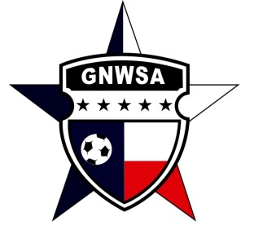

# SOCCER FINANCIAL AID REQUEST

Greater Northwest Soccer Association (GNWSA) wants to provide every child the opportunity to play soccer. If financial constraints prevent a parent from registering their child, financial aid may be awarded for ***one*** season. The GNWSA financial aid form, along with a registration form for each child, must be returned to the GNWSA Registrar before the season’s registration deadline.

Applying for financial aid does not guarantee approval. A majority vote of the GNWSA Board of Directors is required. If financial aid is approved the parent(s) may be asked to volunteer their time (see below).

1. Child’s Name _____________________________________ Birth Date___/___/___

Last First

2. Child’s Name _____________________________________ Birth Date___/___/___

Last First

Parent/Guardian Name ________________________________________

Last First

Address __________________________ City _______________Zip __________

Home Phone ____________________ Work/Cell Phone ____________________

Reason for requesting scholarship: ____________________________________________________________

____________________________________________________________

Season Applying for: Fall 201__ Spring 201__

**NOTE:**

If financial aid is awarded, GNWSA may ask the parent to volunteer for up to **8 hours** of service during the season. Work may include, but may not be limited to field painting, opening or closing fields on Saturdays, helping at registration or other duties as deemed necessary by the Board.

Parent/Guardian Signature _______________________ Date__________

## Please submit to: [registrar@gnwsa.com](mailto:registrar@gnwsa.com) or mail to GNWSA, PMB 141, 1224 N. Hwy. 377, Roanoke, TX 76262

### This form is for **OFFICIAL ASSOCIATION USE ONLY** and is the **PROPERTY OF GNWSA**